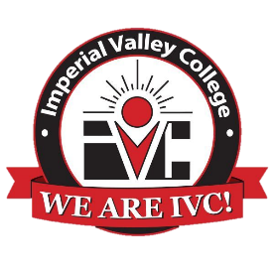

Imperial Valley College
Agriculture Program
Advisory Committee Meeting
Agenda
Thursday October 10, 2024

- Call to Order
- Welcome and Introductions
- Approval of Minutes from November 2, 2023
- Status of the Agriculture Program (Efrain/Andres/Michael)
- AG Club and Master Gardening Initiative (Candice Cano)
- USDA-NIFA Learning to Leading (L2L) Program (Richard Luna)
- Internships and the process (Richard Luna & Genaro Ayala).
- Input from Industry representatives
- Other
- Adjourn

