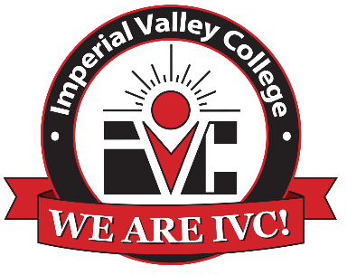

Digital Design & Production
Program Advisory Committee Meeting

Thursday, Oct 4, 2024
12:00pm – 1:00 p.m.
Board Room

Agenda

- Call to Order
- Welcome
- Approval of Minutes from 10-25-2022
- D.D.P. Program and Course Overview
- Program Performance
- Program Feedback, Changes, and Recommendations
  - Move to 2023 Adobe Classroom in a Book
  - Industry Certifications on Campus
  - New Courses?
    - InDesign, After Effects, Lightroom
- Voting Item: Approval of Computer Systems Purchased for DDP Lab
- Voting Item: Adoption of Local Drop Box for Instructional Purposes
- Voting Item: Industry Approval of Program Viability
- Next Meeting
- Other
- Adjournment

