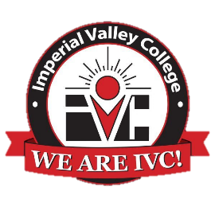

Accounting Technician Advisory Meeting
Agenda
November 16, 2023

- Welcome and Purpose – Dean Efrain Silva

- Introductions – All

- Approval of Minutes – Alison Brock

- Program Summary – Alison Brock

- Roundtable Discussion of Trends in Accounting – Todd Hansink

- Other

- Adjourn

