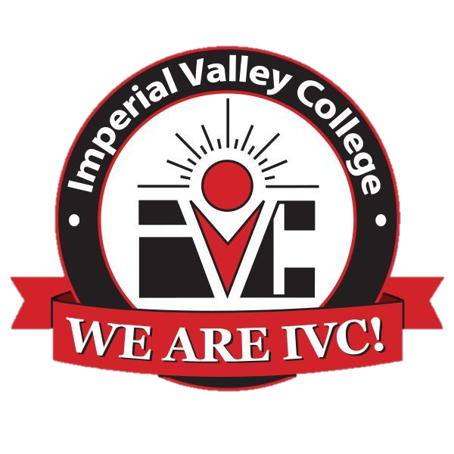

Imperial Valley College
Agriculture Program
Advisory Committee Meeting
Agenda
Thursday November 2, 2023

- Call to Order
- Welcome and Introductions
- Approval of Minutes from October 20, 2022
- L2L Grant
- Diesel Program
- Industrial Automation Program
- Chemical Lab Technician Program
- Career Services
- Re-establishment of Ag Field
- Proposal of BA in Industrial Management
- Other
- Adjourn

