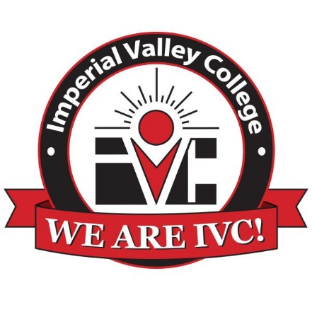

Accounting Technician Program Advisory Committee
IVC Board Room
Thursday, November 4
12 – 1 p.m.

Agenda

- Welcome and Purpose – Dean Efrain Silva

- Introductions – All

- Revised Accounting Technician Program – Alison Brock

- Discussion – Todd Hansink
  - Required Skills
  - QuickBooks & Other Software
  - 10-Key Calculators
  - Other?

- Internship Program – Angie Ruiz

- Selection of Chairperson – Dean Efrain Silva

